DRIVER DROWSINESS DETECTION SYSTEM
A PROJECT REPORT
Submitted by
YASH PATEL (24T28503)

Guided by

ASST. PROF. KHUSHALI SHAH

In fulfillment for the term work of
DESIGN ENGINEERING -II
IN
MECHATRONICS ENGINEERING
School of Technology and Engineering



ITM SLS BARODA UNIVERSITY

Vadodara- 391510, Gujarat

April, 2026



ITM SLS BARODA UNIVERSITY

CERTIFICATE
This is to certify that the final evaluation of project entitled DRIVER DROWSINESS DETECTION SYSTEM YASH PATEL has been carried out on 25.04.2026. The project work meets all the requirements in fulfillment for the term work in Mechatronics Engineering, 6th Semester of ITM SLS Baroda University.

Internal Examiner | External Examiner
Name: | Name:



ITM SLS BARODA UNIVERSITY

CERTIFICATE
This is to certify that the project report submitted along with the project entitled DRIVER DROWSINE-SS DETECTION SYSTEM has been carried out by Yash Patel under my guidance in fulfillment for the term work in Mechatronics Engineering, 6th Semester of ITM SLS Baroda University, Vadodara during the academic year 2025-26.

Asst. Prof. Khushali Shah Asst. Prof. Vishva Adak

Internal Guide Head of the Department



ITM SLS BARODA UNIVERSITY

DECLARATION OF AUTHENTICITY OF REPORT

I/We hereby declare that the Project report submitted along with the Project entitled DRIVER DROWSINESS DETECTION SYSTEM submitted in fulfillment for the term work in Mechatronics Engineering , ITM SLS Baroda University, Vadodara, is an authentic record of original project work carried out by me / us at School of Technology and Engineering under the supervision of Asst. Prof. Khushali Shah and that no part of this report has been directly copied from any students’ reports or taken from any other source, without providing due reference.

Sr no. | Name of the Student | Sign of Student
1 | Yash Patel

Acknowledgement

It is indeed a great pleasure to express our sincere thanks and gratitude to all those who helped us during the development of this project. The success we have got in the accomplishment of the project is not only our individual effort but is the cumulative product of a lot of people. So, with a great pleasure we would like to take this opportunity to express our gratitude to all the individuals who have helped and inspired us in our project work.
We acknowledge with a deep sense of gratitude, the guidance and support received from ASST. PROF. Khushali Shah who approved our project, held faith in it and also for his critical evolution and suggestion regarding the project at every step. We are thankful to our dean and faculties of our department for helping us directly or indirectly in our project.

Abstract

Driver drowsiness is a significant cause of road accidents, leading to serious injuries and loss of life worldwide. The Driver Drowsiness Detection System aims to monitor the driver’s alertness in real time and reduce the risk of accidents caused by fatigue. The system uses computer vision and machine learning techniques to analyze facial features such as eye closure, blinking patterns, and head movements. A camera continuously captures the driver’s video, and image processing algorithms identify signs of drowsiness, including prolonged eye closure and yawning.
When the system detects fatigue, it triggers an alert mechanism such as an audible alarm or vibration to warn the driver and restore attention. The system is non-intrusive, cost-effective, and can be easily integrated into modern vehicles. By providing timely warnings, it helps in preventing accidents and improving road safety, making it a valuable solution for reducing driver-related risks.

Table of contents

Sr. No. | Topic Name | Page No.
1 | Introduction | 1
2 | Objective | 2
3 | Components Used | 3
4 | Circuit Diagram | 7
5 | Working Principle | 8
6 | Software Implementation | 11
7 | Hardware Implementation | 12
8 | Code | 13
9 | Applications | 15
10 | Advantages and Limitations | 16
11 | Conclusion | 17
12 | REFERENCE | 18

CHAPTER: 1 Introduction
Driver drowsiness is one of the major causes of road accidents, especially during long-distance driving and late-night travel. A Driver Drowsiness Detection System helps in identifying signs of fatigue in drivers and provides timely alerts to prevent accidents and improve road safety.
In this project, the Driver Drowsiness Detection System is implemented using a camera, image processing techniques, and a microcontroller or computer-based system. The camera continuously captures the driver’s face, and algorithms analyze features such as eye closure, blinking rate, and yawning. These inputs are processed to determine the level of alertness, and when signs of drowsiness are detected, the system activates an alert mechanism such as a buzzer or vibration to warn the driver.
The main advantage of this system is its non-intrusive nature and real-time monitoring capability. Unlike manual observation, this automated system provides continuous and accurate detection without distracting the driver. It is cost-effective and can be easily integrated into vehicles, making it useful for enhancing road safety. Additionally, such systems form the basis for advanced driver assistance technologies and smart vehicle systems.

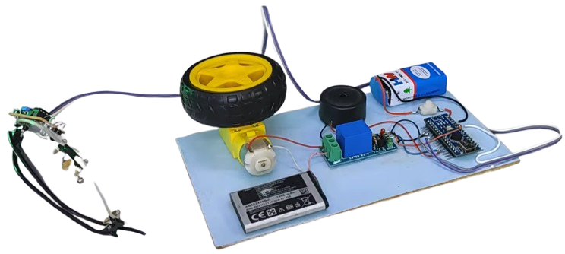

Fig.1 Base Model of Driver Drowsiness Detection System

CHAPTER: 2 Objective

• Design and develop system
Create a smart system that detects driver drowsiness to improve road safety.
• Real-time monitoring
Use a camera to continuously capture and analyze the driver’s face instantly.
• Detect fatigue signs
Identify drowsiness through eye closure, blink rate, and yawning patterns.
• Image processing & ML
Apply computer vision and machine learning to accurately analyze driver behavior.
• Alert system
Activate a buzzer or alarm when drowsiness is detected to alert the driver.
•Real-time safety understanding
Learn how systems respond quickly to prevent accidents.
• Hardware-software integration
Combine camera, microcontroller, and software for smooth system operation.
• Skill development
Gain knowledge in embedded systems, computer vision, and automation.

CHAPTER: 3 Components Used

1. IR Sensor
- Detects eye blinking or closure to identify drowsiness
- Sends digital signals based on eye activity
- Helps in monitoring driver alertness

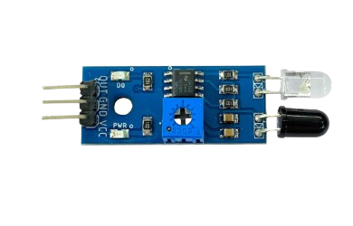
Fig.2 IR Sensor

2. Arduino Nano
- Acts as the brain of the system
- Receives signals from the IR sensor
- Controls buzzer, relay module, and motor based on input

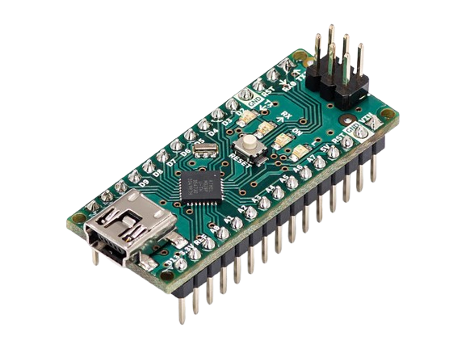
Fig.3 Potentiometer

3. 5V Relay Module
- Acts as a switch to control high-power devices
- Receives signals from Arduino Nano
- Controls the motor operation when drowsiness is detected

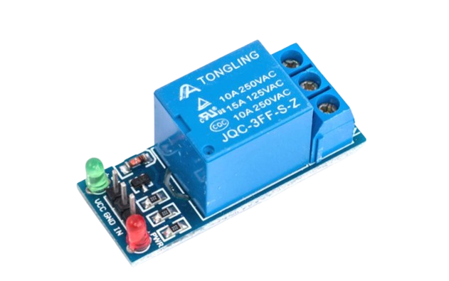

Fig.4 5V Relay Module

4. BO Gear Motor
- Provides motion to simulate vehicle movement
- Controlled by Arduino through the relay module
- Stops or slows down when drowsiness is detected

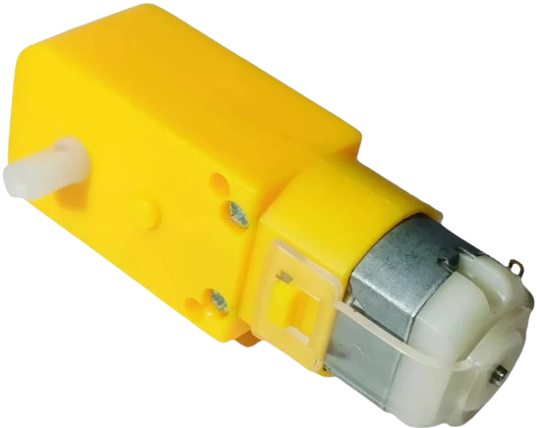

Fig.5 BO Gear Motor

5. Robot Wheel
- Attached to the motor for movement
- Helps in demonstrating vehicle motion.
- Supports smooth rotation during operation.

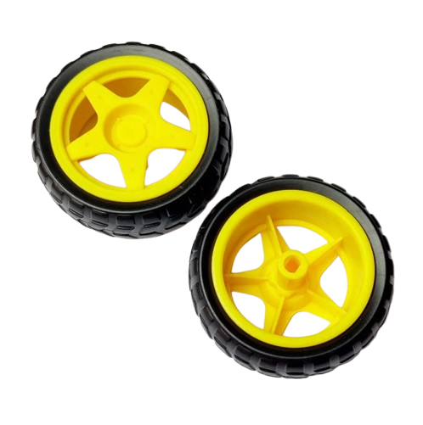

Fig.6 Robot Wheel

6. Average PCB Mounting CT Buzzer
- Produces sound alert when drowsiness is detected
- Warns the driver immediately
- Enhances safety by providing instant feedback

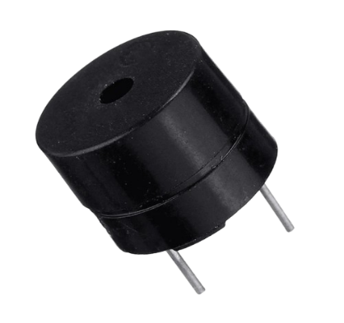
Fig.7 Buzzer

7. 9V Battery (2)

- Provides power supply to the system
- Ensures portable operation
- Supplies required voltage to Arduino and components


Fig.8 Parts 9V Battery

CHAPTER: 5 Circuit Diagram

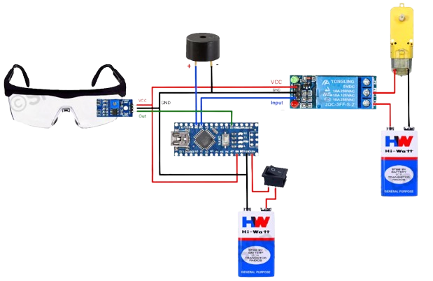

Fig.9 Driver Drowsiness Detection System circuit diagram

CHAPTER: 6 Working Principle

- The IR sensor acts as the input unit to detect eye blinking and closure
- Arduino Nano acts as the control unit and processes the input signals
- Relay and motor act as the output unit to control vehicle movement
- Buzzer provides alert when drowsiness is detected
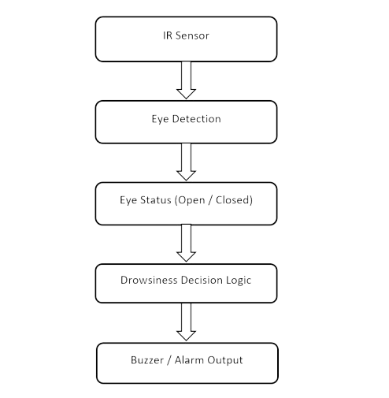

Fig.10 Working Diagram (Block Diagram)

Input Unit (IR Sensor)
The IR sensor acts as the input unit to detect the driver’s eye activity.
- When the driver’s eyes are open, the IR sensor detects normal reflection.
- When the eyes are closed for a longer duration, the reflection changes.
- This change generates a digital signal indicating drowsiness
Thus, eye movement is converted into electrical signals.
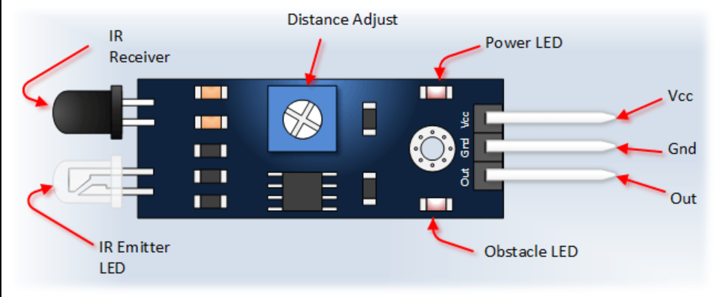

Fig.11 Input Unit (IR Sensor)

2. Signal Acquisition by Arduino
The signals generated by the IR sensor are sent to the Arduino Nano.
- The Arduino reads the digital input from the sensor pin.
- It continuously monitors the signal in real time.
- The input determines whether the driver is alert or drowsy.

3. Processing of Input Signal
After receiving the signal, the Arduino processes the data.
- If normal eye activity is detected → system remains in normal state.
- If eye closure is detected for a longer time → drowsiness condition is triggered.
- Decision-making logic is implemented in the program.

4. Control Signal Generation
Based on the processed input, Arduino generates output signals.
- Sends HIGH/LOW signals to buzzer and relay module.
- Controls alert system and motor operation.
- Ensures quick response to drowsiness detection.

5. Output Unit (Buzzer & Motor Control)
The output components respond according to Arduino signals.
- Buzzer turns ON to alert the driver..
- Relay module activates/deactivates the motor.
- Motor stops when drowsiness is detected, simulating vehicle stop.

6. Real-Time Operation
The system works continuously in a loop::
• Detection → Signal → Processing → Alert/Control → Action
This ensures real-time monitoring and immediate response to drowsiness.

CHAPTER: 7 Software Implementation

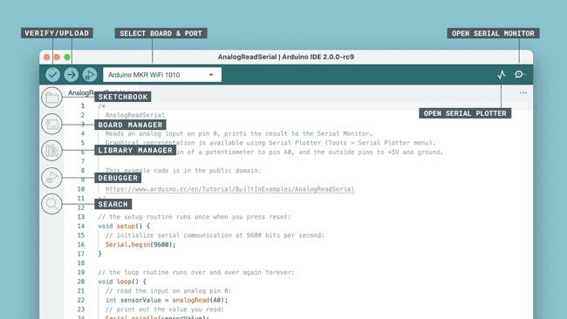
● Arduino IDE – used for writing and uploading the program

Fig.12 Arduino IDE
- Capturing the Input

- Arduino reads digital signals from IR sensor
- Determines eye open/close condition

- Processing Logic

- If (eyes closed for few seconds) → Drowsiness detected
- Else → Normal condition

CHAPTER: 8 Hardware Implementation

- Raspberry Pi used as the main processing unit for running detection algorithms
- Camera module used instead of IR sensor to capture real-time driver video
- Computer vision techniques used to analyze eye closure and facial features
- System directly connected to Car ECU for controlling vehicle functions
- Alert system integrated with ECU to trigger actions like speed reduction or warning
- API integration used to send drowsiness alerts to web/mobile portal
- Internet connectivity enables real-time monitoring and data transmission
- System works continuously for real-time driver safety monitoring

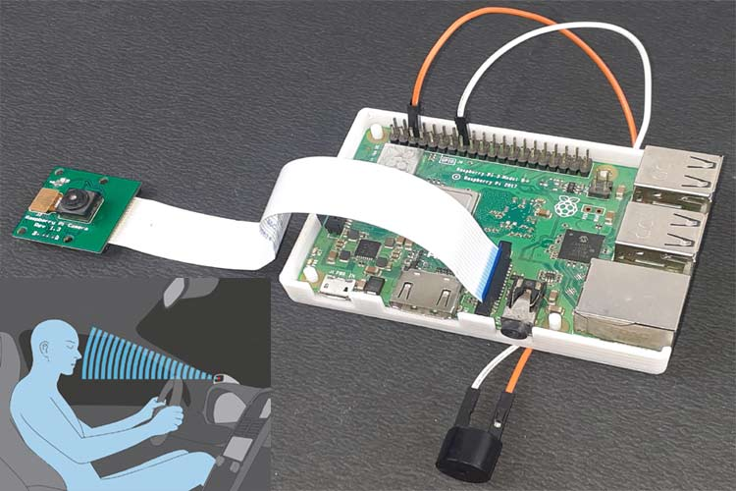

Fig.13 Assembled Driver detection system

CHAPTER: 9 Code

// Driver Drowsiness Detection System
// Arduino Nano

const int sensorPin = 2; // IR Eye Blink Sensor
const int buzzerPin = 9; // Buzzer
const int motorPin = 8; // Vibration Motor

long eyeCloseTime = 0;
bool eyeClosed = false;

// IMPORTANT: Sensor logic change if needed
bool detectState = LOW; // LOW = eye closed (common case)

void setup() {
pinMode(sensorPin, INPUT);
pinMode(buzzerPin, OUTPUT);
pinMode(motorPin, OUTPUT);

digitalWrite(buzzerPin, LOW);
digitalWrite(motorPin, LOW);

Serial.begin(9600);
}

void loop() {

int sensorState = digitalRead(sensorPin);
Serial.println(sensorState);

// Eye CLOSED detected
if (sensorState == detectState) {

if (!eyeClosed) {
eyeCloseTime = millis(); // time start
eyeClosed = true;
}

long duration = (millis() - eyeCloseTime) / 1000;

// ⏱️ 2 sec → Warning
if (duration >= 2) {
digitalWrite(buzzerPin, HIGH); // 🔊 Buzzer ON
}

// ⏱️ 4 sec → Strong Alert
if (duration >= 4) {
digitalWrite(motorPin, HIGH); // ⚙️ Motor ON (vibration)
}

}

// Eye OPEN
else {
eyeClosed = false;

digitalWrite(buzzerPin, LOW); // Buzzer OFF
digitalWrite(motorPin, LOW); // Motor OFF
}
}

CHAPTER: - 10 Applications

1. Road Safety Enhancement
The system plays a crucial role in reducing road accidents caused by driver fatigue.
- Detects drowsiness in real time and alerts the driver immediately
- Helps in preventing accidents during long-distance and night driving
- Improves overall safety for drivers, passengers, and pedestrians

2. Automotive Industry (Smart Vehicles)
The system can be integrated into modern vehicles as a safety feature.
- Works as part of Advanced Driver Assistance Systems (ADAS)
- Can be connected with vehicle systems to control speed or trigger warnings
- Enhances smart and autonomous vehicle capabilities

3. Fleet Management Systems
Used in commercial transport vehicles for monitoring drivers.
- Helps companies track driver alertness remotely
- Reduces accidents in logistics and delivery operations
- Improves driver performance and accountability

4. Public Transportation
Useful in buses, taxis, and long-route transport services.
- Ensures safety of passengers by monitoring driver condition
- Reduces risk in long-hour driving jobs
- Can send alerts to control centers using API integration

5. Research and Development
Used for developing advanced AI-based safety systems.
- Helps in testing computer vision and machine learning models
- Used in academic and industrial research projects
- Supports innovation in intelligent transportation systems

6. Personal Safety Systems
- Provides affordable safety solution for daily use
- Easy to install and operate
- Helps in preventing fatigue-related accidents

CHAPTER :- 11 (A) Advantages

- Improves road safety significantly
- Real-time monitoring and alert system
- Non-intrusive and easy to use
- Can be integrated with IoT and smart systems

CHAPTER :- 11 (B) Limitations

- Accuracy may vary with lighting conditions
- Requires proper camera positioning
- Can be affected by driver accessories (glasses, masks)
- Depends on continuous power supply

CHAPTER: 12 Conclusion

The Driver Drowsiness Detection System provides an effective solution to reduce accidents caused by driver fatigue. By using sensors or camera-based monitoring along with real-time alert mechanisms, the system ensures timely warnings and enhances safety. It also serves as a foundation for advanced smart vehicle technologies and intelligent transportation systems.

The Driver Drowsiness Detection System is developed to minimize road accidents caused by driver fatigue by providing continuous and intelligent monitoring of the driver’s state. The system uses a camera or sensor-based setup to capture real-time data of the driver’s face and behavior. It focuses on key indicators of drowsiness such as prolonged eye closure, reduced blinking rate, frequent yawning, and head movement patterns.
Using image processing techniques, the system detects facial features like eyes and mouth from video frames. Machine learning algorithms are then applied to analyze these features and classify the driver’s condition as alert or drowsy with high accuracy. The system operates in real time, ensuring that any signs of fatigue are identified immediately without delay.
Once drowsiness is detected, the system activates an alert mechanism such as a buzzer, alarm sound, or vibration to warn the driver and help them regain focus. This quick response plays a crucial role in preventing accidents and improving overall road safety.
In addition, the project demonstrates the effective integration of hardware components (camera, microcontroller, alert system) with software technologies (computer vision and machine learning). It also provides a strong foundation for future advancements in smart vehicles, driver assistance systems, automation, and intelligent transportation systems, making it highly relevant in modern automotive safety solutions.

CHAPTER: 13 REFERENCE

- Arduino Official Website.
Available at: https://www.arduino.cc/
- Arduino IDE Documentation.
Available at: https://docs.arduino.cc/
- Raspberry Pi Foundation Official Documentation.
Available at: https://www.raspberrypi.org/documentation/
- OpenCV Library Documentation.
Available at: https://opencv.org/
- Python Software Foundation.
Available at: https://www.python.org/
- Research Paper:
“Driver Drowsiness Detection System Using Machine Learning” – IEEE Papers.
- YouTube Tutorial:
Driver Drowsiness Detection Project
https://youtu.be/CRUpaNY-b2E
- Component Datasheets:
IR Sensor Module Datasheet
Arduino Nano Datasheet
Relay Module Datasheet
Buzzer and Motor Specifications
Online Learning Platforms:
Instructables

